

FURTHER MATHEMATICS
TRIAL EXAMINATION 1
2013
SOLUTIONS

SECTION A – answers SECTION B – answers

Core Module 1 Module 2 Module 3 Module 4 Module 5 Module 6
Number Geometry Graphs Business Networks Matrices
Patterns & & related &
Trig Relations Maths Decision

Maths
1. C 1. C 1. E 1. B 1. D 1. C 1. E
2. C 2. B 2. C 2. D 2. E 2. E 2. C
3. C 3. E 3. B 3. A 3. D 3. D 3. E
4. D 4. D 4. D 4. E 4. E 4. B 4. B
5. B 5. C 5. D 5. E 5. B 5. A 5. D
6. D 6. B 6. C 6. A 6. D 6. C 6. D
7. E 7. C 7. C 7. C 7. B 7. C 7. A
8. E 8. D 8. B 8. C 8. A 8. E 8. D
9. A 9. C 9. D 9. E 9. A 9. D 9. C
10. E
11. D
12. B
13. D

SECTION A - solutions

Core – Data analysis

Question 1

The mode is the most frequently occurring piece of data. So the mode is 47
The answer is C.

Question 2

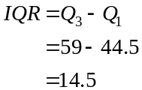
Note that Q₃ is the midpoint of the higher data values and Q₁ is the midpoint of the lower data values.
The answer is C.

Question 3

Enter the data into your calculator and obtain the one-variable statistics for the data set.
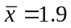 and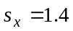 (both correct to one decimal place)
The answer is C.

Question 4
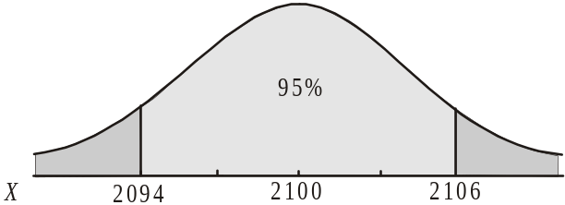
Using the rule, 95% of
containers will lie between 2 standard
deviations either side of the mean; that is,
between 2094g and 2106g.
So 5% will weigh less than 2094g and
more than 2106g.
The answer is D.

Question 5

So there are 37 year 12 students (to the nearest whole number) who don’t have a learners permit.
The answer is B.

Question 6

Option A, B, C and E are all true.
Option D is not true since the median rent paid at Lowtown is $1000 per m² per year. At Broadside, 75% of retail tenants pay more than $900 per m² per year.
The answer is D.

Question 7

The dependent variable (vertical axis on scatterplot or y variable) is final weight.
So the independent variable (horizontal axis on scatterplot or x variable) is initial weight.
Enter the data into your CAS.

The answer is E.

Question 8

Having keyed in all the data to find the least squares regression line equation, read off the value of r, which is Pearson’s product-moment correlation coefficient and
The answer is E.

Question 9

From the formula sheet we have 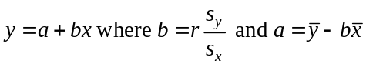.
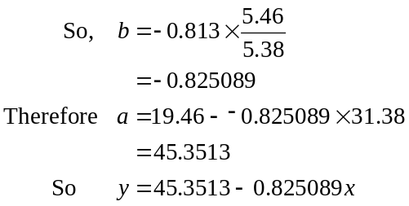
The closest equation is 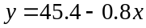
The answer is A.

Question 10

The first four plots are suitable to use in an effort to linearise the data.
The plot number of patrons against (maximum temperature)² is not.
This plot could be used to linearise data that looks like

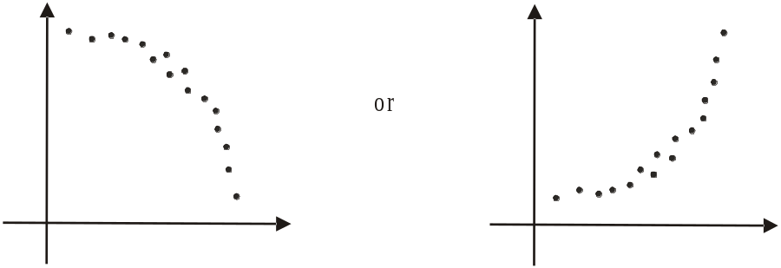

The answer is E.

Question 11

When fitting a regression line the variables should be numeric.
So option A is incorrect.
Because there is an obvious outlier a least squares regression line is not suited so option B is incorrect.
The data is clearly linear (with an outlier) so a transformation is not required. So option C is incorrect.
A 3-median regression line would be appropriate because there is an outlier.
So option D is correct.
The answer is D.

Question 12

For the months of June, July, August, September and October, the median number of pairs of shoes sold was 2 900 which is the June sales figure. This is because during two months (i.e. August (3 200) and October (3 500)) more were sold and during two months (i.e. July (2 600) and September (2 600)) less were sold.
The answer is B.

Question 13

The regression line has endpoints located at (0, 85 000) and at (20, 50 000) where 20 is the twentieth quarter in the period 2008 – 2012.
The gradient of the regression line is therefore
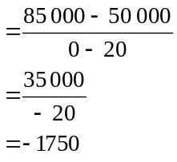
According to the regression line, there was on average a decrease in profit of $1750 each quarter.
The answer is D.
SECTION B

Module 1: Number patterns

Question 1

The sequence 8, 15, 22, 29,… is arithmetic since .
Generate the sequence on your CAS.
The tenth term is 71.
The answer is C.

Question 2

The number of parts produced by the machine each hour forms an arithmetic sequence given by
850, 900, 950, 1000,…
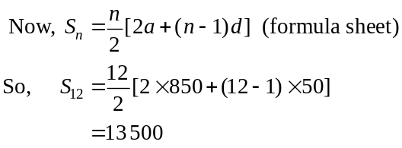
The answer is B.

Question 3

The terms of a Fibonacci sequence are generated by adding two successive terms to create the next term. The only pair of numbers that add to give 1 are – 5 and 6. So – 5 and 6 could be the first two terms.
The answer is E.

Question 4

We have a geometric sequence with and
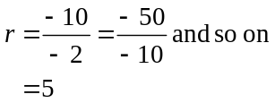
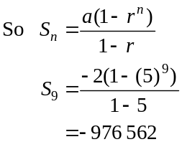
The answer is D.

Question 5
An infinite sum of a geometric sequence can be calculated if r, the common ratio of the sequence, is greater than – 1 and less than 1.
For option A,
For option B,
For option C,
So an infinite sum cannot be calculated for this series.
The answer is C.

Question 6

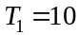 for all the options.
Looking at the graph, if 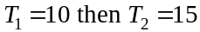.
Option A generates 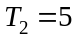
Option B generates 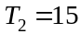
Option C generates
Option D generates
Option E generates 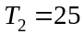
So eliminate options A and E.
Again from the graph, 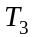 appears to be around 22 or 23.
Option B generates 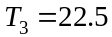
Option C generates 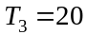
Option D generates 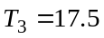
So eliminate options C and D.
The answer is B.

Question 7
Method 1
The sequence generated by the difference equation 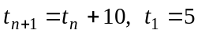 is 5, 15, 25, 35, …
Option A generates the sequence 6, 7, 8, 9,…
Option B generates the sequence 11, 12, 13,…
Option C generates the sequence 5, 15, 25, …
The answer is C.
Method 2
The sequence generated by the difference equation is arithmetic with 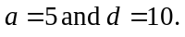
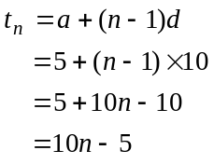
The answer is C.

Question 8
Initially there are 180 patients having been referred who are awaiting treatment. So 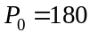.
This eliminates option A.
The number of patients referred each month increases by 12% so we need to multiply P_{n} by 1.12 to reflect this. Note that which does not represent growth! Whereas, does.
Also 20 patients are treated each month and don’t need to come back.
So, 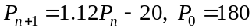
The answer is D.

Question 9

The sequence, 5, 4, 3.2, … is geometric because 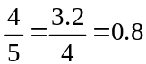
If this sequence continues indefinitely, the total amount of weight lost will be given by
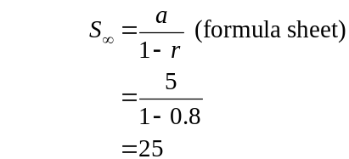
So Jo will end up weighing 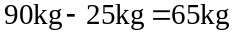
The answer is C.
Module 2: Geometry and trigonometry

Question 1

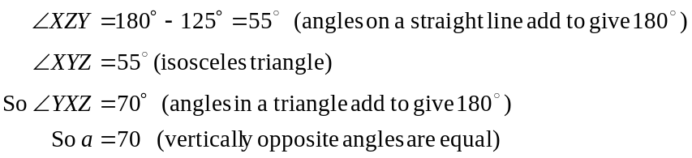
The answer is E.

Question 2

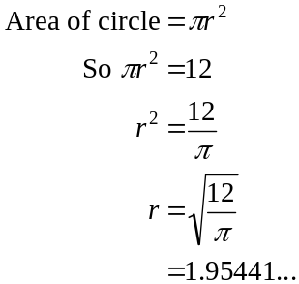
The answer is C.

Question 3

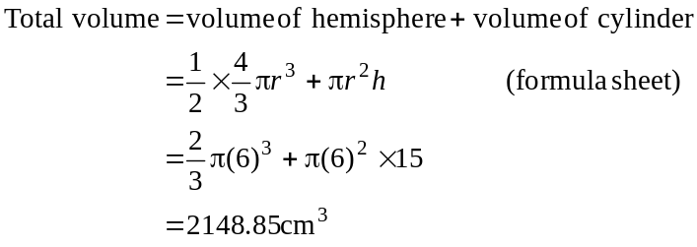
The closest answer is 2 149cm³.
The answer is B.

Question 4

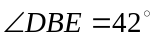 since AC and BD are parallel (alternate angles in parallel lines)
In ,
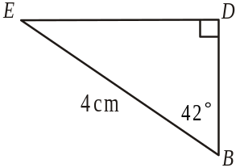
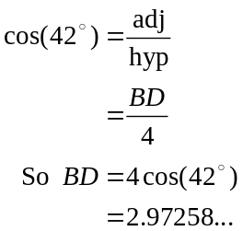
The closest answer is 2.97cm.
The answer is D.

Question 5

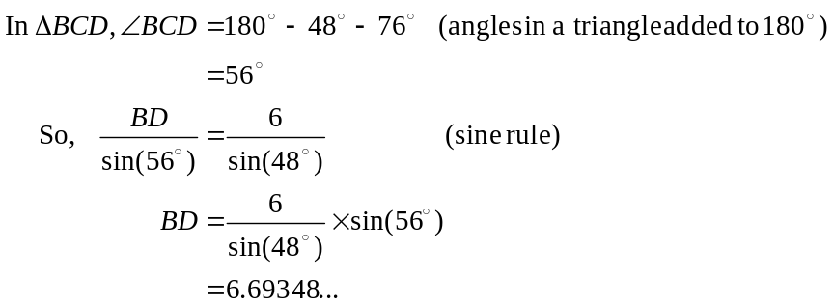
The closest answer is 6.69cm.
The answer is D.

Question 6

ratio of volumes is
which simplifies to
So the ratio of the volumes is or 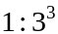
So the ratio of the lengths i.e. radius and height will be
In the smaller cone
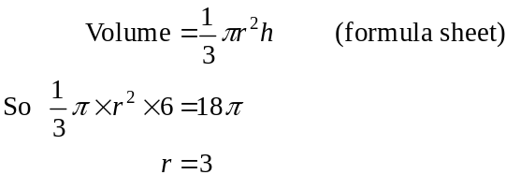
So the radius of the larger cone is .
The answer is C.

Question 7
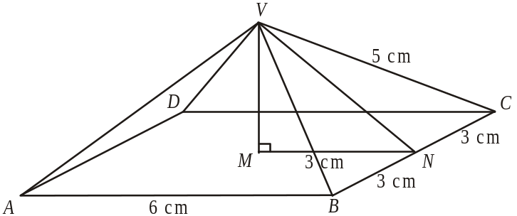

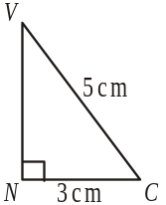
Let N be the midpoint of BC.
In ,
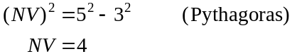

In ,
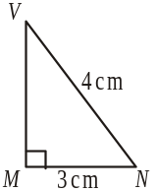
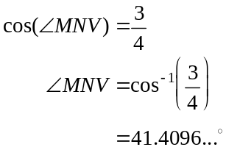
The closest answer is 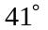.
The answer is C.

Question 8

Option A shows an even increase in the height which the contour map does not indicate so eliminate option A.
Option C shows the height at A as 10m which is incorrect, it is 5.
So eliminate option C.
Option E shows the height at D as 35m which is incorrect, it is 40 so eliminate option E.
Option D shows a correct cross-section until the last two line segments approaching D which are incorrect.
The answer is B.

Question 9

Draw a diagram.
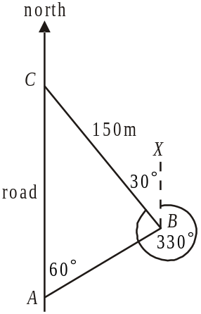
Since 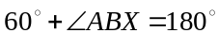, then 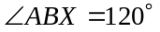.
(cointerior angles in parallel lines add to give 180°)
Therefore 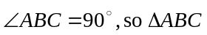 is a right-angled triangle.
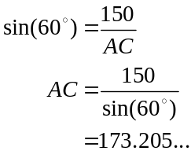
The closest answer is 173m.
The answer is D.

Module 3: Graphs and relations

Question 1

The equation of the line is 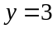.
Note that some of the points that the line passes through are 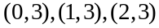 and so on. The simple equation that satisfies all these points is .
The answer is B.

Question 2

1 book would cost 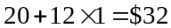
2 books would cost 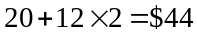
3 books would cost 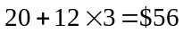
5 books would cost 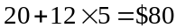

The answer is D.

Question 3

1 hour and 7.5 hours costs 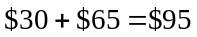
So option A is correct.
Option B costs 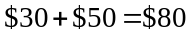
Option C costs 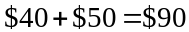
Option D costs
Option E costs
The answer is A.

Question 4

On days 1, 2, 3, 5, 6, 9 and 10 the humidity was increasing so option A is true.
The average rate of change of humidity over the 10 days was 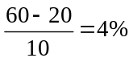 per day so option B is true.
The humidity was above 50% on day 3, 4, 5, 6, 7, part of day 8 and part of day 10 so C is true.
On day 2 the average rate of change of humidity was 20 and the same on day 3 so D is true.
On day 7 the rate at which the humidity changed was – 15% per day. On day 9 it was +15% per day. So option E is not true.
The answer is E.

Question 5

The inequality defines the region to the right of the line . The inequality defines the region above the line.
The inequality defines the region above and to the left of the line since the point 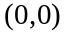 (for example) lies in this region and satisfies the inequality i.e. .
The inequality defines the region below and to the right of the line since the point (for example) lies in this region and satisfies the inequality i.e. .
The inequality defines the region above and to the right of the line since the point (for example) does not lie in this region.
That is, it doesn’t satisfy the inequality i.e. is not true.
The region defined by could therefore not be used to define the feasible region shown.
The answer is E.

Question 6

The gradient of the straight line shown is 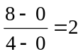.
The equation of the straight line is therefore
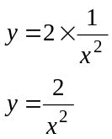
The answer is A.

Question 7

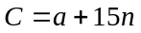
At break-even point,
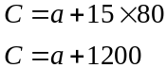
At break-even point, the revenue is
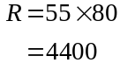
At break even point,
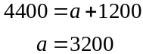
The answer is C.

Question 8

The inequality 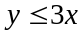, represents the constraint that Celia can spend up to three times as much of her weekly study time on Accounting as she does on studying English.
The inequality 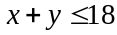, represents the constraint that Celia has 18 hours of study time available to her each week. In other words, she can, if she chooses, use up to 18 hours.
The two inequalities are given in option C.
The answer is C.

Question 9

Method 1 – sketch the region

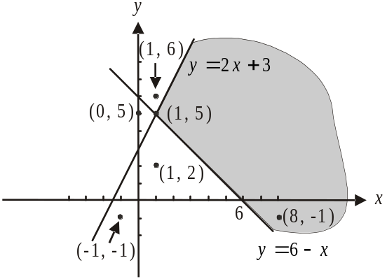

The defined region is shaded. Only the point 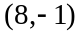 lies in the region.
The answer is E.

Method 2 – algebraically
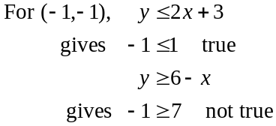

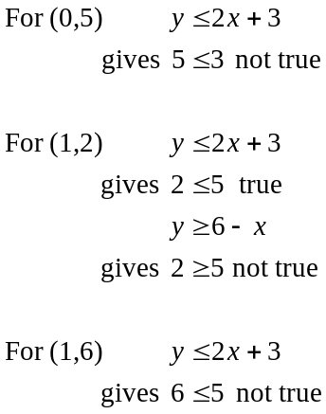

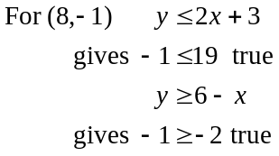
The answer is E.
Module 4: Business-related mathematics

Question 1

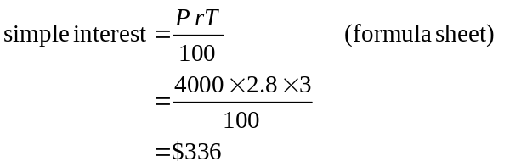
The answer is D.

Question 2

The minimum balance for April is $3 140.56.
The interest calculated is simple interest.
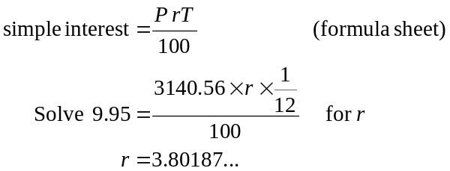
Note that the time is 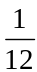 of a year or a month.
The closest answer is 3.8%.
The answer is E.

Question 3

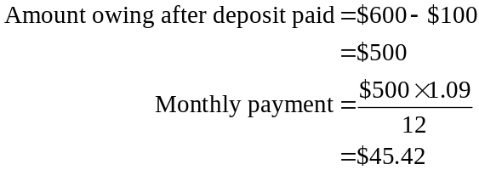
The answer is D.

Question 4

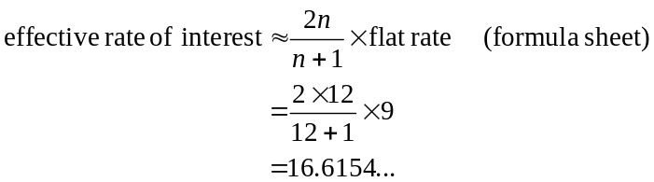
The closest answer is 17%.
The answer is E.

Question 5

After two years the value of Ky’s investment was .
Solve 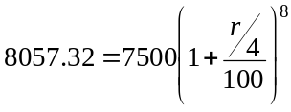 for r using CAS.
Note that this is the annual rate, the quarterly rate is which is what appears in the formula.
Also, over 2 years, there are 8 quarters.
The answer is B.

Question 6

The retailers turnover for August would be
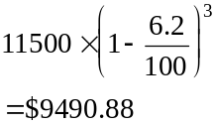
since there were three ensuing months.
The answer is D.

Question 7

Use TVM

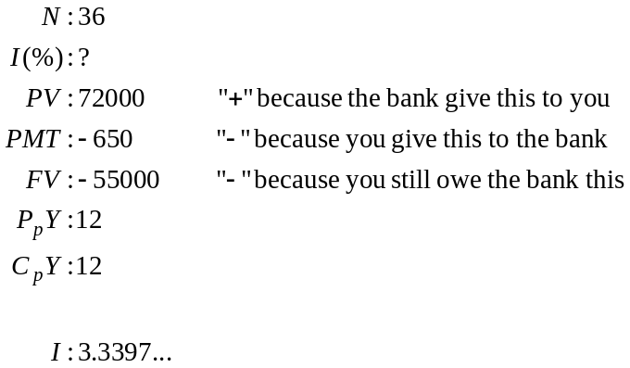

The closest answer is 3.3%.
The answer is B.

Question 8

From the graph we see that Jane’s salary is increasing, but the increases are by a bit more each year than the previous year. This indicates exponential growth which could be given by option A. Check, when 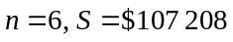 which is feasible from the graph. Option E shows exponential growth too but checking 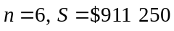 which is not verified by the graph.
The answer is A.

Question 9

Because this is a reducing balance loan we use TVM. Start by finding out how much George still owes after 8 years.

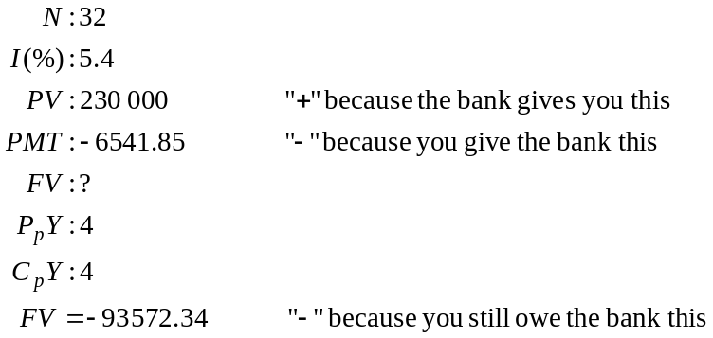
So George still owes $93 572.34.

Using TVM again, for the last 4 years of the loan, we have

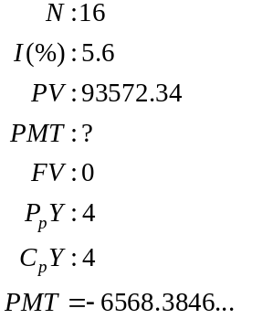
So George’s new payments will be $6568.38.
The answer is A.

Module 5: Network and decision mathematics

Question 1
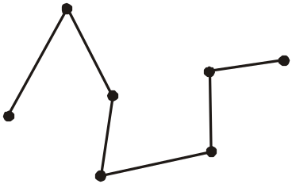

Three edges are needed. The graph above shows one possible spanning tree – there are many others. The graph is connected, and has no circuits.
The answer is C.

Question 2

A Hamiltonian circuit starts and finishes at the same vertex and passes through all other vertices on the graph just once.
All 5 vertices can have an Hamiltonian circuit start there.
For example,

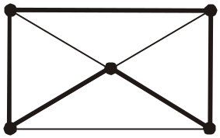
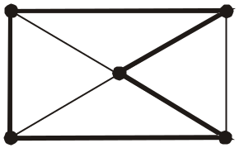

The answer is E.

Question 3

Audrey has a two-step dominance over Norma (Audrey – Rose – Norma) and over Rose (Audrey – Portia – Rose) and over Mildred (Audrey – Portia – Mildred).
So Audrey has a two-step dominance over 3 of the other chooks.
The answer is D.

Question 4

The network is such that a cut must go through the top, middle and bottom line of edges.
The minimum flow on the top line is 3, the minimum flow on the middle line is 4 and the minimum flow on the bottom line is 3.
So the minimum cut is .
Therefore the maximum flow is 10.
The answer is B.

Question 5

To find the number of edges on the graph, sum the elements of the matrix above the leading diagonal of the matrix.
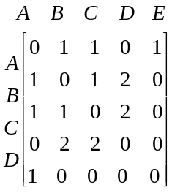
Alternately, you can sum the entries below the leading diagonal of the matrix – you will get the same answer.
There are 8 edges.

Since the graph is planar, we can use Euler’s formula which is on the formula sheet.
So 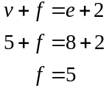
The answer is A.

Question 6

The total capacity is .
Note that the other two edges (with capacities of 7 and 2) which the cut crosses, are flowing in the opposite direction i.e. from sink to source not source to sink. They are therefore ignored (not subtracted!).
The answer is C.

Question 7

If we have an Euler circuit then it must finish as well as start at A. It must pass through every edge just once.
Statement 1 is true for example
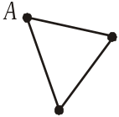

Statement 2 is untrue since if it starts and finishes at A and passes through every edge, vertex A cannot have an odd degree.
Statement 3 is untrue since a tree cannot contain a circuit.
Statement 4 is true as shown in the diagram above.
Statement 5 is untrue, because for an Euler circuit to exist all vertices must have an even degree.
So two of the statements are true.
The answer is C.

Question 8

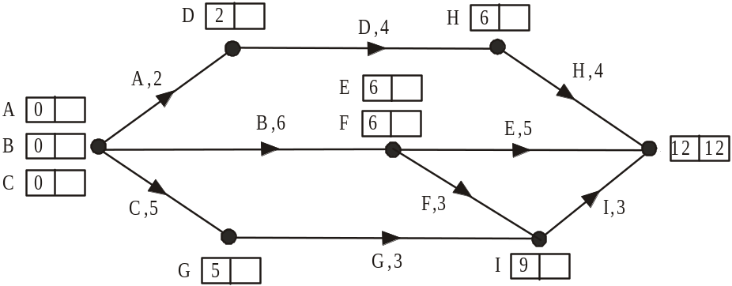

Just finding the earliest start times for all the activities gives us the minimum time in which the project can be finished which is 12 hours.
The answer is E.

Question 9

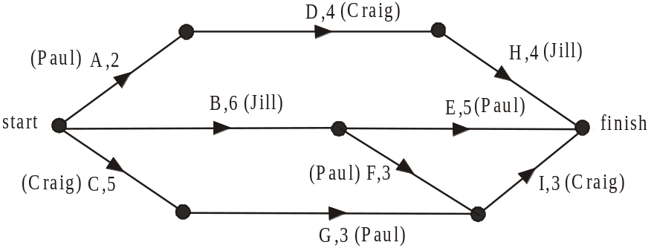

 | Hours
 | 1 | 2 | 3 | 4 | 5 | 6 | 7 | 8 | 9 | 10 | 11 | 12 | 13 | 14 | 15 | 16
Paul | A | A |  |  |  | G | G | G | F | F | F | E | E | E | E | E
Jill | B | B | B | B | B | B |  |  |  | H | H | H | H
Craig | C | C | C | C | C | D | D | D | D |  |  | I | I | I

The three staff members can each start with a task, Paul with activity A, Jill with activity B and Craig with activity C.
Paul finishes activity A after 2 hours but has to wait until Craig finishes activity C before Paul can start activity G.
After finishing activity C, Craig can start activity D. When he finishes that, Jill can start activity H. She is then done with the project.
Meanwhile Paul has finished activity G so he can now start activity F, (rather than E, because Craig is waiting for him to finish activity F). After Paul finishes activity F he can start activity E.
Meanwhile Craig can now start activity I.
The minimum time it will take is 16 hours.
The answer is D.
Module 6: Matrices

Question 1

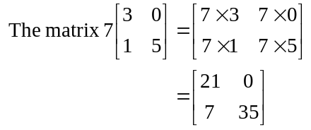
The answer is E.

Question 2

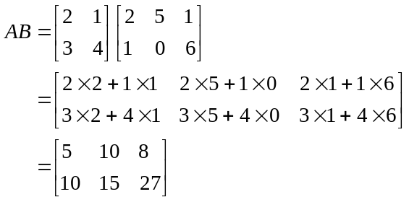
The element in the second row and first column of matrix AB is 10. It is obtained by calculating .
The answer is C.

Question 3

PQ
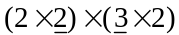

PQ is not defined since the number of columns of P does not equal the number of rows of Q. 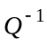is not defined since Q is not a square matrix; that is, not a etc matrix.

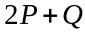 is not defined because 2P is a matrix and Q is a matrix and because the two matrices have a different order they cannot be added.

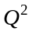
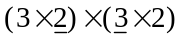
is not defined because the number of columns of Q does not equal the number of rows of Q.

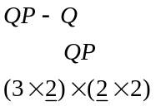
QP is defined and it is a matrix.
Since Q is also a matrix, 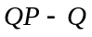 is defined.
The answer is E.

Question 4

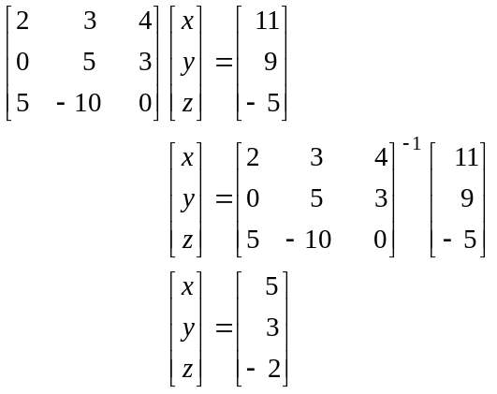
The answer is B.

Question 5

For option A multiplying the first two matrices of order 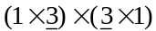 gives us a matrix of order .
Multiplying this matrix with a matrix; 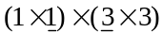 is not defined.
For option B, multiplying the first two matrices of order 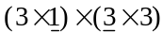 is not defined.
For option C, the same problem arises as in option B.
For option D, multiplying the first two matrices gives us 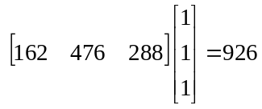.
Option E gives us a matrix as an answer whereas we want a matrix with the total number of pairs of shoes.
The answer is D.

Question 6

Looking at the first column of the given table, which shows morning flights, there are 2 first class, 5 business and 11 economy tickets left.
This gives us the first row of our solution matrix so we can eliminate options A, B and C.
Looking at the second column of the given table, which shows afternoon flights, there are 3 first class, 11 business and 7 economy tickets left. This gives us the 2nd row of our solution matrix. Already we see that only option D can be correct.
The answer is D.

Question 7

The transition diagram tells us that 60% of the students who attend the lecture one week will attend it the next week. It also tell us that 15% of the students who viewed the lecture on line one week will attend the lecture the next week.
We can enter this information as below.

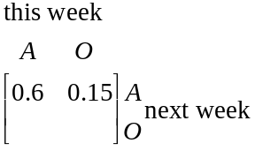
Since the columns of a transition matrix must add to give 1, we can complete the matrix. Alternatively you can use the remaining information given on the transition diagram.

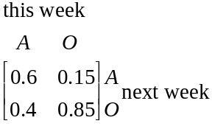
The answer is A.

Question 8

Of those who take public transport to the office, none change to take the option of driving to the office.
Of those who drive to the office one day, only 90% of them will drive the next day and of them only 90% will drive the next day and so on.
Over time there will be no staff who drive to the office.
The answer is D.

Question 9

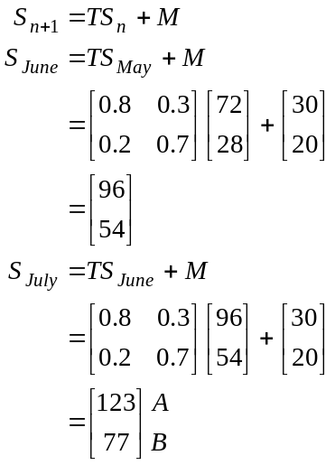
The number taken to shopping centre B in July is 77.
The answer is C.

